MARCH 4 2019 - 4:00AM

Raising Grandchildren: Frank and Geraldine talk about caring for their grandchildren

Isabel Bird

What's On
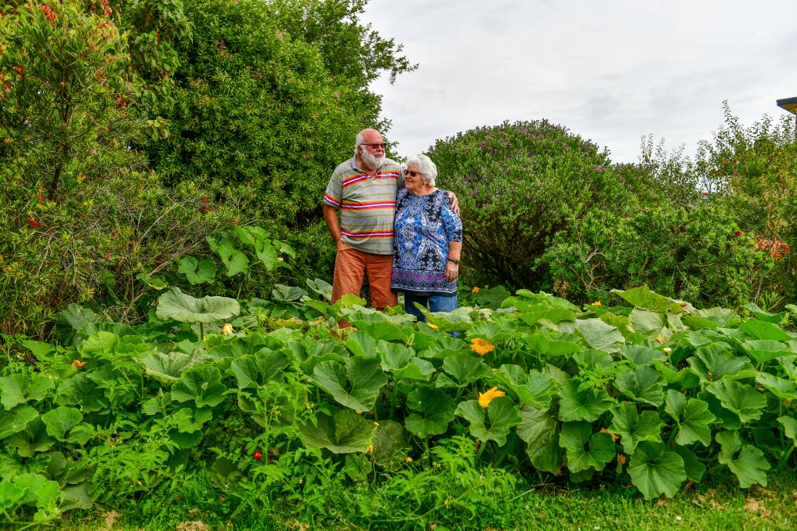
Frank, 72, and Geraldine, 76, are raising three young girls who arrived into their care wearing nappies, aged one, two and three.
The grey nomad life was almost upon them.
Newly remarried Frank and Geraldine had both nursed former spouses through sickness until death and then found each other.
Both nearing 70 years, they saved their funds and planned their retirement getaway; the caravan sat in the driveway. Yet this dream was not theirs to have.
A phone call from Tasmania's Child Protection Services changed the course of their older lives.
"Child protection rang up from Hobart and said the kids were not going back to their Mum," Frank said.
"We had an hour to make our decision about whether to take them on."
The kids in question were his son's children, aged one, two and three.
The youngest was already in full-time foster care, and the middle child was at the burns unit in hospital after a boiling water incident.
This latter event ultimately prompted Frank and Geraldine's life-changing call.
Frank, who had spent several years caring for foster children with his previous wife, knew the realities of the system and said it was never a question of whether they would take the children.
"There is no way we wanted them in foster care. They would have been split up and we would never have seen them again," he said.
The parenting of young children is never easy.
A full-time responsibility of changing nappies, feeding, putting down to sleep, dressing and teaching.
No two kids are alike and all have their individual demands.
In the case of the babies and toddler that came to permanently live with Frank and Geraldine all had serious behavioural, medical, or psychological needs.
Geraldine stressed that the children are their life.
"They are our reason for living and that is just the way it is. If we ever lost them it would be devastating," she said.
Frank added, "you put your life on hold, you re-adjust your lifestyle, you raise the kiddies, and you enjoy it." The grandparents started looking for support groups in their area.
Geraldine said opportunities to simply catch up with friends were minimal, and the social isolation could take a personal toll.
"You lose your friends because you no longer have anything in common with them, and you are too old to join in with the younger parents who are also raising kids," she said.
"You can't run around, or play sport, or easily go down to the beach. So you need to have a group that you can relate to, who you can go to for assistance."
Frank admitted that spending enough time with their other grandchildren was difficult. Both were hesitant to admit to any health problems, which would naturally put stress on any family dynamic.
For Frank, it was a back operation that put him out of action for eight weeks, and Geraldine had heart bypass surgery. "There are no support mechanisms in place, no respite," Frank said.
"Geraldine was out of action and we had to try and seek government assistance for around the home but the response was 'we only provide this for older people who need it, why don't you get the kids to do it for you?'"
The couple joined the support group Grandparents Raising Grandchildren which in 2017 was reformed and renamed Kin Raising Kids Tasmania, of which Frank is chief executive.
The group exists to raise public awareness about the pressures faced by grandparent carers and wants to see greater government support for both formal and informal carers.
It also wants to educate about the positives of raising grandchildren, believing that children should, wherever possible, live with biological family members instead of being sent into the foster care system.
Frank said a majority of the group's members are informal, where grandparents care for children without statutory or court-based orders, and without government assistance. Formal carers, in comparison, care for children under Magistrate Division court orders and raise the children alongside Child Protection Services who allocate caseworkers and have a say in major decisions related to the child.
"A lot of the informal carers are women on a pension living on their own. Their children have dumped the kids onto them and walked away," Geraldine said.
"They care for the kids voluntarily which means they don't qualify for any support payments unless they then take the kids to the department but they don't do that because they fear they will lose the kids."
Informal carers do not receive automatic carers payments, such as those received by foster and formal carers, and many do not apply for Commonwealth government allowances despite being eligible for them.
A common reason for this is that completing the necessary paperwork is just too difficult or impossible, even after the introduction of Centrelink Grandparent Advisers to assist.
Frank said substance-addicted parents will often not sign the necessary statutory declarations to transfer Centrelink payments to grandparents, or grandparents failed to ask parents due to fear or the risk of parents demanding the return of children. He said it is the kids that ultimately suffer.
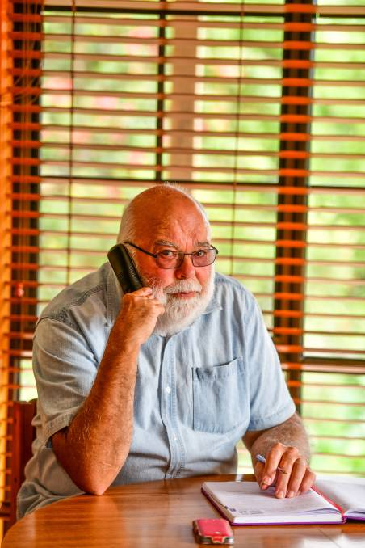
Kin Raising Kids chief executive Frank wants to see greater government support for grandparent carers.
"A lot of the grandparents are too frightened to pursue the cause. In many instances, it is their kids' drug money and they might get violent," he said.
"There is also a lot of stigmas associated with these situations and families don't want to be embarrassed so they just put up with it and get on with life."
This lack of extra financial assistance can, in turn, impede children's access to specialist medical and psychological support.
"There are so many drug-related and domestic violence issues in so many cases and invariably a big percentage of these kiddies have complications so you need to link up with paediatricians and specialist services," he said.
"Kids under formal care usually get higher priority, which just makes it so cruel for the informal ones."
Frank said informal grandparents were forced to find and pay for services out of their own pockets if that was even possible.
"They end up getting poorer and poorer. You just hope the kids are going to get well."
While sacrifices are made and hardships experienced by grandparents as a result of becoming primary caregivers to children, most would never change their situations.
They just want recognition and support.
"Life is not dull at all. There is a lot of love and affection in this house, there really is, we have our moments but who doesn't," Geraldine said.
Their main concern is the children, to ensure they have the same experiences and opportunities as any other Tasmanian child.
Frank asks "why should the kiddies suffer through life because of this system?"
- Raising Grandchildren is a series looking at the challenges faced by elderly couples and singles who have children in their full-time care.

