**KINSHIP CARE IN TASMANIA**

# A SURVEY TO IDENTIFY THE GREATEST NEEDS

The results of this questionnaire will be used to write a report about the most pressing needs of kinship carers in Tasmania. The report will be published and posted to all those who participate in the survey. The report will also be made freely available to the public. Kin Raising Kids Tasmania Inc. guarantees that no personal details of kinship carers who participate in the survey will be revealed and that not one personal situation will be identifiable in the report.

|  |
| --- |
| ***Stage 1 of this survey closed on November 20th so that an interim report will be written in 2017.***  ***Stage 2 Surveys collected after November 20th will inform the final report expected within 6 months.*** |

1. Name
2. Postal address
3. E/mail address
4. Telephone number:
5. Number of children being raised
6. Ages of children:
7. How many years have you been a kinship carer?
8. Your relationship to the children being raised? (circle one)
9. grandparent aunt uncle sister brother other: ……………………………………
10. What are your top 3 greatest needs? (Please tick only 3)

⇨ financial support

⇨ medical support for you

⇨ medical support for the children in your care

⇨ access to social activities

⇨ training and information to assist you in your role as kinship carer

⇨ information about government policy affecting your role

⇨ Appropriate respite

⇨ Other: ……………………………………………………………………………………………………………………

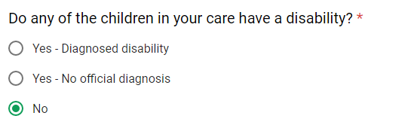

|  |  |
| --- | --- |
|  | |
|  |

Comments:



**Please**

**post**

**this**

**completed survey or phone/email your response to**

**:**

Returning officer

Wendy Roberts

4

Hawley Place

, Hawley Beach 7307

Ph: 03 6428 7274 Email:

wendyroberts43@hotmail.com